[Slow Cooker Tacos Al Pastor (pineapple chile pork)](http://paleopot.com/2013/02/slow-cooker-tacos-al-pastor-pineapple-chile-pork/" \o "Permanent Link to Slow Cooker Tacos Al Pastor (pineapple chile pork))

[Jason](http://paleopot.com/author/admin/) | February 7, 2013 | [23 Comments](http://paleopot.com/2013/02/slow-cooker-tacos-al-pastor-pineapple-chile-pork/#comments)

[2K+](http://www.pinterest.com/pin/create/button/?url=http%3A%2F%2Fpaleopot.com%2F2013%2F02%2Fslow-cooker-tacos-al-pastor-pineapple-chile-pork%2F&media=http%3A%2F%2Fpaleopot.com%2Fwp-content%2Fuploads%2F2013%2F02%2Fpastor1.1.jpg&guid=FALNKu25wQ0X-0&description=Slow%20Cooker%20Tacos%20Al%20Pastor%20%28pineapple%20chile%20pork%29)

You’ll want to open your own taco truck…

How can you go wrong with a marinade of pineapple and chili peppers? I’ve been craving this recipe ever since I had a taste from a taco truck years ago. I’m sorry for making you dirty up your food processor or blender to make this one, but you’ll get over it. This recipe provides some flexibility, as you can use the authentic dried guajillo chiles, or just some easy to find chipotles in adobo sauce (call the paleo police, I know). I even (gasp) used canned pineapple because the market I went to was out of fresh. The only hard part of this recipe is waiting for the meat to marinate. Also, don’t let this cook while you’re home, the amazing smell will be torture and the hours will seem like weeks. I warn you now! I can’t wait to try this same marinade on some beef, and cheat on my slow cooker and grill it! Crazy, I know. Before you ask, yes you can adjust the spicy levels to your liking. Do remember that hot peppers mellow out some after slow cooking, yet I know not everyone loves the spicy like I do. It’s ok, now on we go with making tacos…

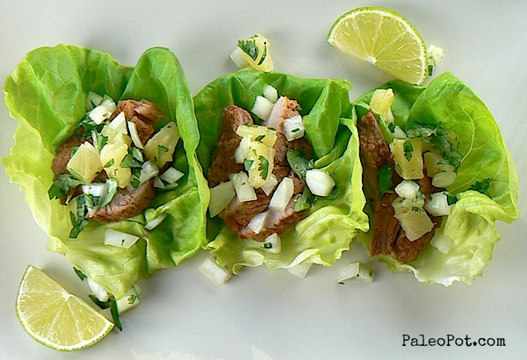

What you need:

* One [3 pound pork shoulder, roast, or tenderloin](http://www.grasslandbeef.com/StoreFront.bok?affId=136651). I used a shoulder.
* 6 [dried guajillo chili peppers](http://www.amazon.com/gp/product/B007IVF5FE/ref=as_li_qf_sp_asin_il_tl?ie=UTF8&camp=1789&creative=9325&creativeASIN=B007IVF5FE&linkCode=as2&tag=pale0e-20) (rehydrated in water) or 6 chipotles in adobo sauce (easier to find).
* One 8 ounce can of crushed pineapple (juice and all), or 2 cups of fresh pineapple, chopped.
* One cup of white onion, diced.
* Half a cup of orange juice, or the juice of two large oranges.
* 4 cloves of garlic, smashed.
* 1 Tbsp of apple cider vinegar.
* 1 tsp of oregano.
* 1 tsp of cinnamon.
* 1 tsp of cumin.
* 1 tsp of black pepper.
* 1 tsp of sea salt.
* one large ziplock bag for the pork to marinade in.
* optional: add or subtract chili peppers/powder to your personal taste.
* Salsa garnish: equal amounts of pineapple, white onion, and cilantro with a touch of lime juice.

How you make it:

1. If using dried chilis, boil them in a small saucepan until fully rehydrated and softened, then drain.
2. In a blender or food processor, combine your chiles, pineapple, orange juice, garlic, onion, vinegar, and spices.
3. Puree your marinade until an even consistency is obtained.
4. Trim all excess fat off of your cut of pork.
5. Place your pork in your large ziplock bag and pour in your marinade.
6. Make sure your pork is evenly coated and remove as much air as possible from your bag before sealing.
7. Let your pork marinade for at least 2 hours, yet overnight is worth the wait and flavor. I let mine go 18 hours.
8. Dump your pork and marinade into your slow cooker.
9. Cook on low for 6 to 8 hours.
10. Shred or slice your pork as you see fit, mixing in some of the delicious marinade and pork juices.
11. Serve in crisp lettuce wraps.
12. Garnish with a simple salsa made of equal parts pineapple, white onion, and cilantro, with a touch of lime juice.
13. Watch these disappear fast!